**COMPSCI 589: MACHINE LEARNING**

**PROJECT 3 REPORT**

**Student:** Trung Dang – 33858723

1. Task 1

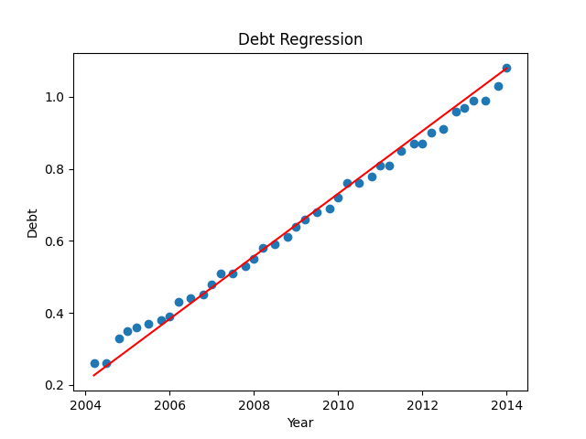

* The equation of the fitted line is:

Y = -1.7421213e+02 + 8.7036580e-02 * x

* The total predicted student debt in 2030 is: 2.4721222

1. Task 2

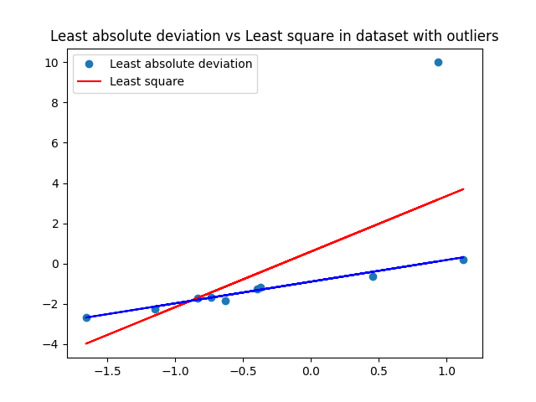

* The equation of the least squares regression line:

Y = 0.59446543 + 2.7611253 * x

* The equation of the least deviation regression line:

Y = -0.898 + 1.0770425 * x